策略分析报告[35] 2013-01-07 - 2018-10-18 (1407 days)

# 1、策略回测收益曲线

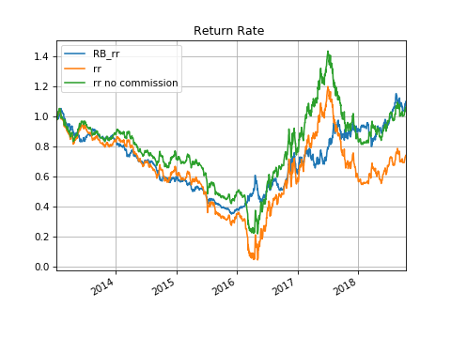

# 2、策略回撤曲线

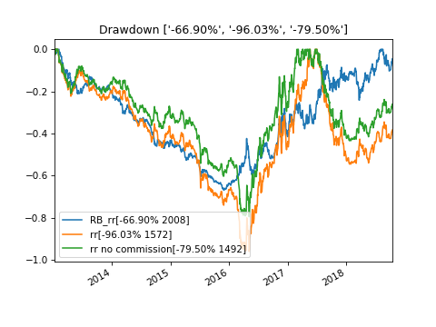

# 3、散点图矩阵图（Scatter Matrix）

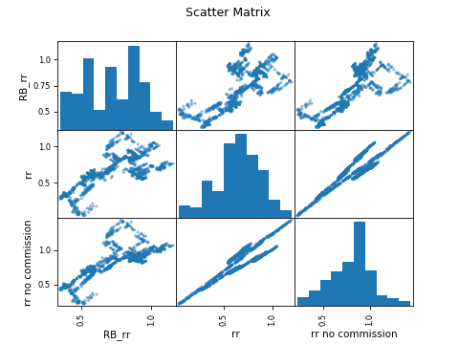

# 4、相关性矩阵图（Correlation）

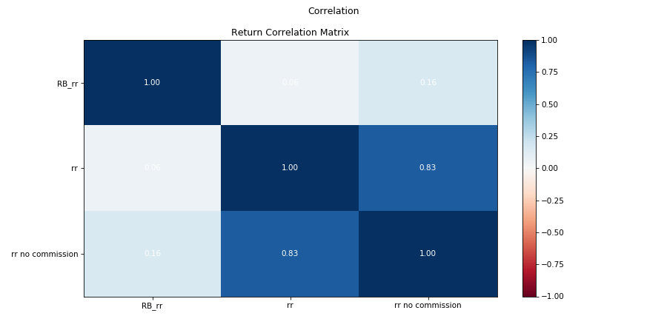

# 5、绩效统计数据（Porformance stat）

|  |  |  |  |
| --- | --- | --- | --- |
|  | **RB_rr** | **rr** | **rr no commission** |
| **start** | 2013-01-07 | 2013-01-07 | 2013-01-07 |
| **end** | 2018-10-18 | 2018-10-18 | 2018-10-18 |
| **rf** | 0.03 | 0.03 | 0.03 |
| **total_return** | 7.83% | -26.92% | 4.04% |
| **cagr** | 1.31% | -5.28% | 0.69% |
| **max_drawdown** | -66.90% | -96.03% | -79.50% |
| **calmar** | 0.02 | -0.05 | 0.01 |
| **mtd** | 4.16% | 5.51% | 3.83% |
| **three_month** | 8.82% | 0.19% | 1.44% |
| **six_month** | 24.42% | 14.23% | 13.56% |
| **ytd** | 19.54% | 20.32% | 19.54% |
| **one_year** | 22.39% | 8.15% | 13.02% |
| **three_year** | 40.73% | 30.86% | 31.19% |
| **five_year** | 4.77% | -2.06% | 4.19% |
| **ten_year** | 1.31% | -5.28% | 0.69% |
| **incep** | 1.31% | -5.28% | 0.69% |
| **daily_sharpe** | 0.07 | 0.35 | 0.12 |
| **daily_sortino** | 0.11 | 0.69 | 0.20 |
| **daily_mean** | 0.05 | 0.39 | 0.07 |
| **daily_vol** | 0.26 | 1.01 | 0.37 |
| **daily_skew** | 0.11 | 6.88 | 1.11 |
| **daily_kurt** | 3.37 | 126.46 | 15.12 |
| **best_day** | 6.88% | 121.48% | 22.09% |
| **worst_day** | -8.10% | -46.62% | -14.04% |
| **monthly_sharpe** | 0.04 | 0.29 | 0.14 |
| **monthly_sortino** | 0.08 | 0.73 | 0.26 |
| **monthly_mean** | 0.04 | 0.29 | 0.09 |
| **monthly_vol** | 0.26 | 0.91 | 0.41 |
| **monthly_skew** | 0.30 | 3.43 | 0.28 |
| **monthly_kurt** | 1.34 | 22.98 | 4.35 |
| **best_month** | 20.79% | 165.80% | 41.53% |
| **worst_month** | -23.33% | -78.64% | -44.95% |
| **yearly_sharpe** | 0.22 | 0.03 | 0.14 |
| **yearly_sortino** | 0.53 | 0.06 | 0.33 |
| **yearly_mean** | 0.12 | 0.04 | 0.08 |
| **yearly_vol** | 0.44 | 0.42 | 0.35 |
| **yearly_skew** | -0.12 | 0.49 | 0.49 |
| **yearly_kurt** | -2.66 | -0.37 | -0.40 |
| **best_year** | 62.01% | 63.92% | 57.25% |
| **worst_year** | -35.68% | -42.75% | -30.42% |
| **avg_drawdown** | -10.23% | -20.51% | -9.58% |
| **avg_drawdown_days** | 261.00 | 260.12 | 121.18 |
| **avg_up_month** | 6.66% | 18.19% | 9.75% |
| **avg_down_month** | -0.05 | -0.10 | -0.07 |
| **win_year_perc** | 60.00% | 60.00% | 60.00% |
| **twelve_month_win_perc** | 50.85% | 30.51% | 35.59% |

# 6、买卖点记录

